**ST. XAVIER’S COLLEGE**

**(Affiliated to Tribhuvan University)**

Maitighar, Kathmandu



**Computer Graphics Lab Assignment**

**Submitted by:**

Suraj Nepal

013BSCCSIT042

**Submitted to:**

|  |  |
| --- | --- |
| Er.Anil Sah  Lecturer, St. Xavier’s College |  |

**Date of Submission:** Tuesday, August 04, 2015

**Design of checkbox:**

**Source Code:**

**//---------------------------------------------------------------------------**

**#include <vcl\vcl.h>**

**#pragma hdrstop**

**#include "checkbox.h"**

**//---------------------------------------------------------------------------**

**#pragma resource "*.dfm"**

**TForm1 *Form1;**

**//---------------------------------------------------------------------------**

**__fastcall TForm1::TForm1(TComponent* Owner)**

**: TForm(Owner)**

**{**

**}**

**//---------------------------------------------------------------------------**

**void __fastcall TForm1::Button1Click(TObject *Sender)**

**{**

**// to draw rectangle**

**Form1->Canvas->Pen->Width=3;**

**Form1->Canvas->Brush->Color=clWhite;**

**Form1->Canvas->Rectangle(20,20,400,400);**

**Form1->Canvas->MoveTo(20,20);**

**Form1->Canvas->LineTo(400,400);**

**Form1->Canvas->MoveTo(400,20);**

**Form1->Canvas->LineTo(20,400);**

**Form1->Canvas->MoveTo(100,20);**

**Form1->Canvas->LineTo(100,400);**

**Form1->Canvas->MoveTo(200,400);**

**Form1->Canvas->LineTo(200,20);**

**Form1->Canvas->MoveTo(300,20);**

**Form1->Canvas->LineTo(300,400);**

**Form1->Canvas->MoveTo(20,100);**

**Form1->Canvas->LineTo(400,100);**

**Form1->Canvas->MoveTo(20,200);**

**Form1->Canvas->LineTo(400,200);**

**Form1->Canvas->MoveTo(20,300);**

**Form1->Canvas->LineTo(400,300);**

**}**

**//---------------------------------------------------------------------------**

**OUTPUT:**

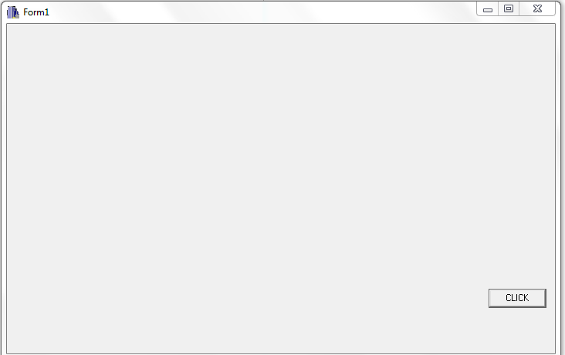

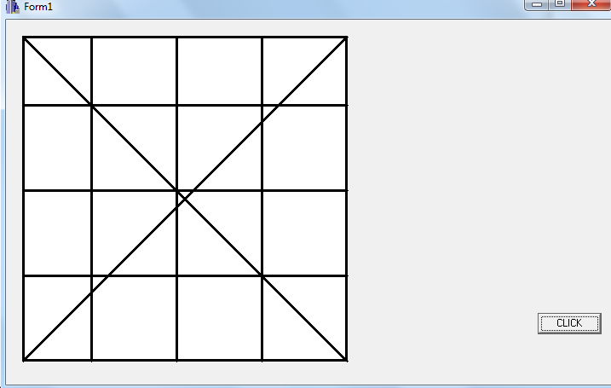

**Reference:**

**[1] Builder1.ppt by Er.Anil Sah.**